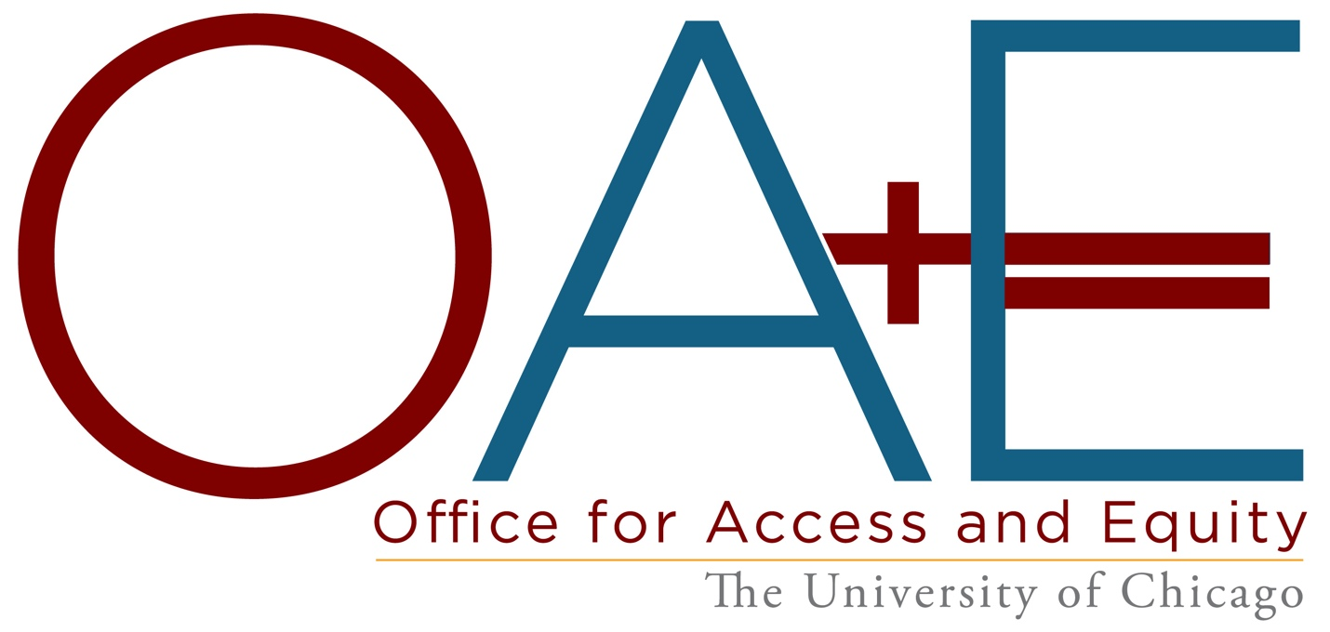

The Office of the Provost’s Equal Opportunity Programs leads and coordinates University efforts to address reports of discrimination, unlawful harassment, and sexual misconduct; to ensure accessibility; and to provide equal employment opportunities. As part of Equal Opportunity Programs, the Office for Access and Equity (OAE) supports the full participation of all members of the University community in the life of the University through a commitment to creativity, fairness, and compassion.

Receives Reports, Provides Support and Resources,

Facilitates Resolution Options

OAE receives and responds to reports, provides support and resources, and offers resolution options, which may include coaching, facilitated conversation, and/or the investigation of complaints made under the University’s Policy on Harassment, Discrimination, and Sexual Misconduct and Policy on Title IX Sexual Harassment alleging that a faculty member, other academic appointee, or postdoctoral researcher engaged in discrimination, unlawful harassment, or sexual misconduct

Report Online

Report by email or phone by contacting,
- For reports regarding faculty, other academic appointees, or postdoctoral researchers: Bridget Collier, bcollier@uchicago.edu or 773.834.6367.
- For reports regarding students: Bridget Collier or the Office for Sexual Misconduct Prevention and Support, titleix@uchicago.edu or 773.834.6367.
- For reports regarding staff: Bridget Collier or Employee and Labor Relations, elrelations@uchicago.edu or 773.834.7345.

Removes Barriers to Participation

OAE determines (and consults with units to implement) reasonable accommodations for faculty, other academic appointees, and postdoctoral researchers on the basis of disability, pregnancy, or risk of contracting serious illness due to COVID19. OAE also coordinates and consults with campus partners on accessibility matters and initiatives.

To request a reasonable accommodation, contact:
- For faculty, other academic appointees, or postdoctoral researchers: Elizabeth Honig, ehonig@uchicago.edu or 773.702.4913.
- For students: Student Disability Services, disabilities@uchicago.edu or 773.702.6000.
- For staff: Employee and Labor Relations, elrelations@uchicago.edu or 773.834.7345.

For additional information regarding resources, visit Access UChicago Now.

Offers Resources and Training

OAE collaborates and shares information on best practices that support a University experience that is inclusive of all participants.

OAE offers information on support and resources, including accommodations and interim measures, to faculty, other academic appointees, or postdoctoral researchers.

OAE consults on and coordinates with campus partners to develop and implement policies, practices, and facilities that support inclusion of all participants, our students, faculty, staff, other academic appointees, postdoctoral researchers, and visitors both with and without disabilities.

OAE facilitates training on discrimination, unlawful harassment, sexual misconduct, accessibility, and conflict resolution.

Review OAE’s training offerings or contact OAE for additional information.

Connects with You

OAE understands that each person’s situation may be unique and there is no one-sized-fits-all approach to addressing a person’s needs. OAE works with other programmatic offices within EOP – the Office for Sexual Misconduct Prevention and Support and the Office for Affirmative Action – on a variety of issues. We encourage community members to contact us with questions or concerns

Elizabeth Honig
Director and Deputy Title IX Coordinator
773.702.4913
ehonig@uchicago.edu

Policies
OAE reviews reports, provides support and resources, and facilitates resolution options under the following University policies:

Policy on Harassment, Discrimination, and Sexual Misconduct

Policy on Title IX Sexual Harassment

Resources Beyond OAE

Emergency Resources
University of Chicago Medicine Emergency Room
773.702.6250
5656 S. Maryland Ave. (24/7)

University of Chicago Police Department
772.702.8181 or 123 from a campus phone (24/7)
850 E. 61st St.

Chicago Police Department
911 (24/7)

Staff and Faculty Assistance Program (Perspectives)
Confidential resource for faculty, other academic appointees, staff, and postdoctoral researchers. (For more information on this confidential resource, visit Get Help)
800.866.7556
www.perspectivesltd.com

Equal Opportunity Programs
Bridget Collier
Associate Provost for Equal Opportunity Programs
Title IX Coordinator, ADA/504 Coordinator, Affirmative Action Officer
773.834.6367
bcollier@uchicago.edu

Other offices: Sexual Misconduct Prevention and Support; Military Affiliated Communities; Affirmative Action

Employee and Labor Relations

Student Disability Services

